Personal Pronouns

🔹 What Are Personal Pronouns?
# Source: AI Source: Provided by: [Data Path: Persons Table -> ID Column: 1, Name_En Column: Motasem Essam] -> From: [Chatgpt (GPT-4-turbo)] on [7/27/2025]
Personal pronouns are pronouns that are used to refer to specific people or things.
They change form depending on:
- Person (1st, 2nd, 3rd)
- Number (singular or plural)
- Case (subject or object)

✅ Forms of Personal Pronouns
# Source: AI Source: Provided by: [Data Path: Persons Table -> ID Column: 1, Name_En Column: Motasem Essam] -> From: [Chatgpt (GPT-4-turbo)] on [7/27/2025]
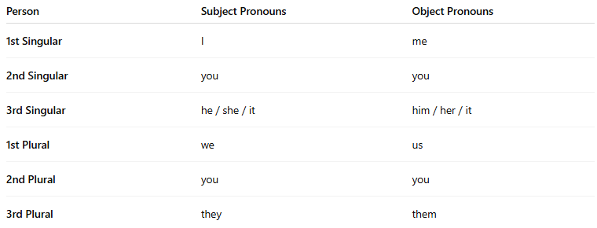
Person | Subject Pronouns | Object Pronouns
1st Singular | I | me
2nd Singular | you | you
3rd Singular | he / she / it | him / her / it
1st Plural | we | us
2nd Plural | you | you
3rd Plural | they | them

what mean of 1st Singular, 2nd Singular ..., 1st Plural ,....
# Source: AI Source: Provided by: [Data Path: Persons Table -> ID Column: 1, Name_En Column: Motasem Essam] -> From: [Chatgpt (GPT-4-turbo)] on [7/27/2025]
Great question! Here's a clear explanation of what 1st person, 2nd person, and 3rd person mean — both in singular and plural forms:

🔹 Person in Grammar
# Source: AI Source: Provided by: [Data Path: Persons Table -> ID Column: 1, Name_En Column: Motasem Essam] -> From: [Chatgpt (GPT-4-turbo)] on [7/27/2025]
In grammar, "person" tells us who is speaking, who is being spoken to, and who or what is being spoken about.
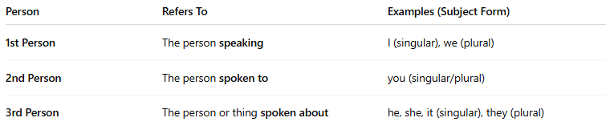
Person | Refers To | Examples (Subject Form)
1st Person | The person speaking | I (singular), we (plural)
2nd Person | The person spoken to | you (singular/plural)
3rd Person | The person or thing spoken about | he, she, it (singular), they (plural)

✅ Singular vs Plural
# Source: AI Source: Provided by: [Data Path: Persons Table -> ID Column: 1, Name_En Column: Motasem Essam] -> From: [Chatgpt (GPT-4-turbo)] on [7/27/2025]
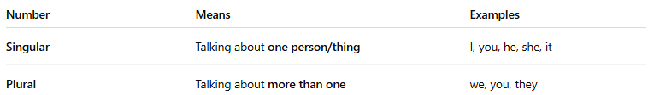
Number | Means | Examples
Singular | Talking about one person/thing | I, you, he, she, it
Plural | Talking about more than one | we, you, they

📚 Combined Table: Person + Number
# Source: AI Source: Provided by: [Data Path: Persons Table -> ID Column: 1, Name_En Column: Motasem Essam] -> From: [Chatgpt (GPT-4-turbo)] on [7/27/2025]
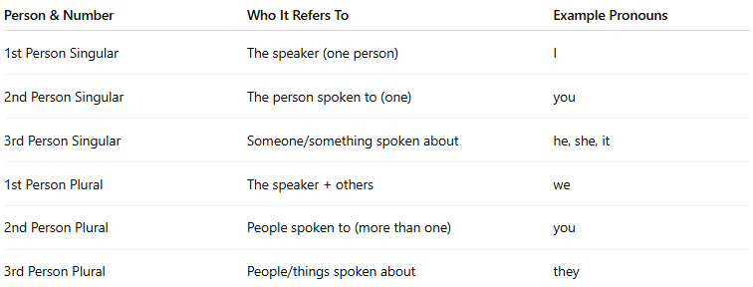
Person & Number | Who It Refers To | Example Pronouns
1st Person Singular | The speaker (one person) | I
2nd Person Singular | The person spoken to (one) | you
3rd Person Singular | Someone/something spoken about | he, she, it
1st Person Plural | The speaker + others | we
2nd Person Plural | People spoken to (more than one) | you
3rd Person Plural | People/things spoken about | they

🧠 Examples in Sentences:
# Source: AI Source: Provided by: [Data Path: Persons Table -> ID Column: 1, Name_En Column: Motasem Essam] -> From: [Chatgpt (GPT-4-turbo)] on [7/27/2025]
- I am a student. (1st singular – talking about myself)
- You are my friend. (2nd person – I'm talking to you)
- He is tall. (3rd singular – I'm talking about him)
- We are happy. (1st plural – me + others)
- They are coming. (3rd plural – talking about other people)

📚 Examples in Sentences
# Source: AI Source: Provided by: [Data Path: Persons Table -> ID Column: 1, Name_En Column: Motasem Essam] -> From: [Chatgpt (GPT-4-turbo)] on [7/27/2025]
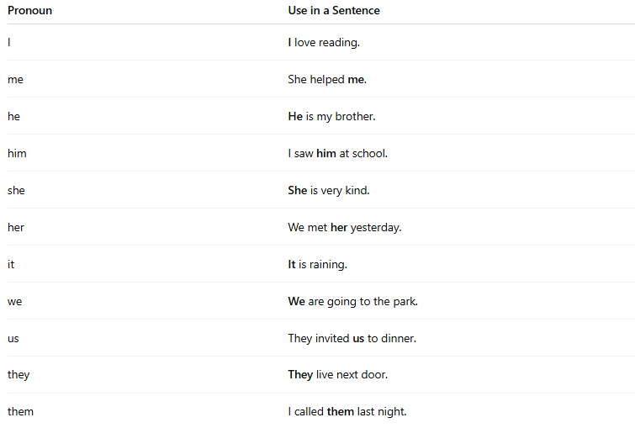
Pronoun | Use in a Sentence
I | I love reading.
me | She helped me.
he | He is my brother.
him | I saw him at school.
she | She is very kind.
her | We met her yesterday.
it | It is raining.
we | We are going to the park.
us | They invited us to dinner.
they | They live next door.
them | I called them last night.

🧠 Notes:
# Source: AI Source: Provided by: [Data Path: Persons Table -> ID Column: 1, Name_En Column: Motasem Essam] -> From: [Chatgpt (GPT-4-turbo)] on [7/27/2025]
- Subject pronouns do the action.
(e.g., She runs fast.)
- Object pronouns receive the action.
(e.g., John likes her.)

